**MEEM 5250 Internal Combustion Engines II**

**10/30/2013**

**SI Combustion Analysis(Part B)**

**Assignment 05**

**Arjun Darbha**

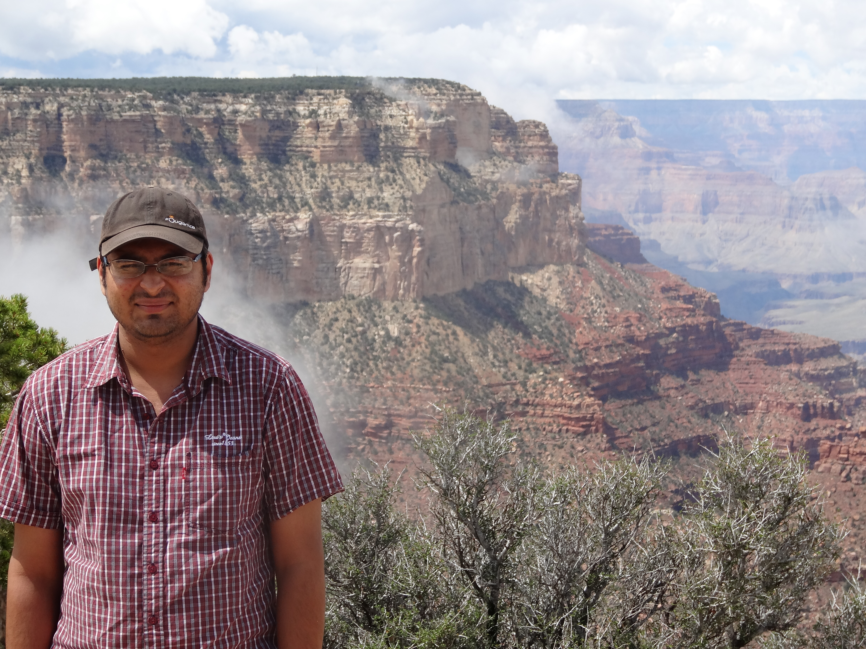

Introduction:

In the previous assignment, pressures have been simulated by calculating heat input into the charge by using EngineSim, a simulator program written in Matlab. This work aims to use experimental cycle data to evaluate the mean PV-diagram. This mean PV diagram is used to calculate IMEP-Gross, net pump and friction by calculating the area under curve using numerical integration techniques. This work can be thought of as a reversed process of the previous homework assignment. Engine test is conducted at a constant speed of 1500rpm and a constant bmep of 2.62bar. Experimental data presented is in the form of .mat files which consists of pressure, volume data with respect to crank angle of 300 cycles. The raw data is initially extracted and transformed into a format useful for plotting and calculating mean of each cycle. As the pressure sensor calibration information is not known, it is calibrated using MAP values at each point which are given in the data supplied. Digital curve smoothing filters are applied on the data extracted as the data presented does not seem to possess a smooth nature. Log-log plots have also been plotted as they are easy to compare in terms of work done by each cycle. This work analyses data of tests 623, 626 and 631.

PART I

A. Almost all the data presented was in SI units except time(msec) and Volume(cm3). Volume given in the data is not used but the crank angle information is used to calculate volume using Heywood 2.6. Time data is converted from sec to msec.

B. The pressures given in the data are recalibrated using reference of MAP. For this “ref_press.m” function that has been supplied with the problem is used.

C. Data was plotted to see that the plots were not smooth. Digital IIR filter called the butterworth filter is used to smooth the curve. A third order filter is used with a cutoff of 0.25 times Nyquist frequency.

D & E. Plots are presented in the subsequent pages. Each column represents the plots of a particular test. First set of plots have three graphs;

1. First plot denotes pressure versus crank angle characteristics overlaid with engine MAP sensor data
2. Second plot denotes a zoomed in view of pressure versus crank angle plot where the y-axis is zoomed into a point until it denotes pressures upto 2 bar
3. Third plot denotes the PV diagram plotted in a log-log axis. Filtered pressure is overlaid on top of the actual pressure data. It is evident that filtered pressure exhibits a smooth curve when compared to non-filtered pressures. Also a log-log plot demonstrates a box-like characteristic which makes it easy to compare the plots and estimate work done in each case without calculating the same.

**Part I**

**Test 623 (6% EGR)**

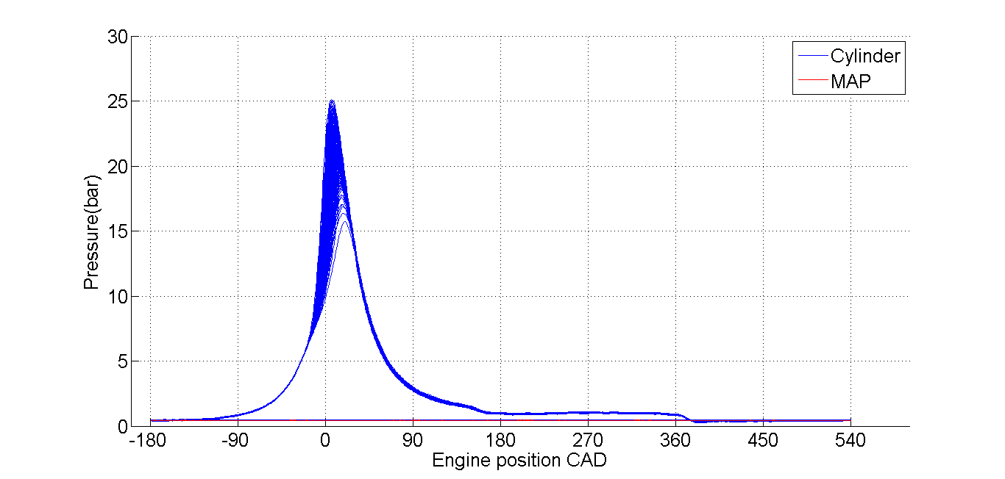

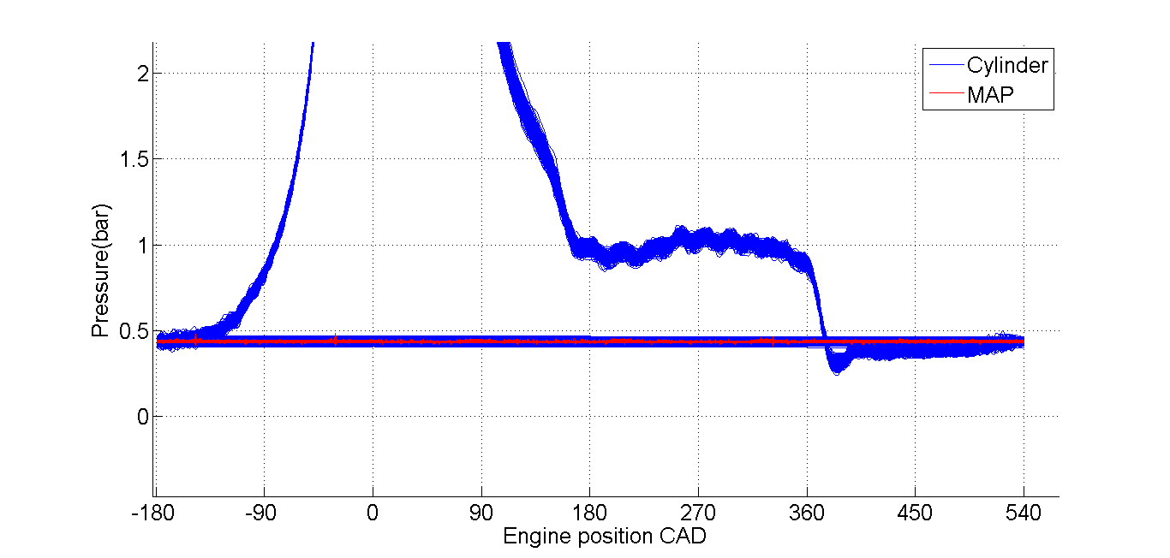

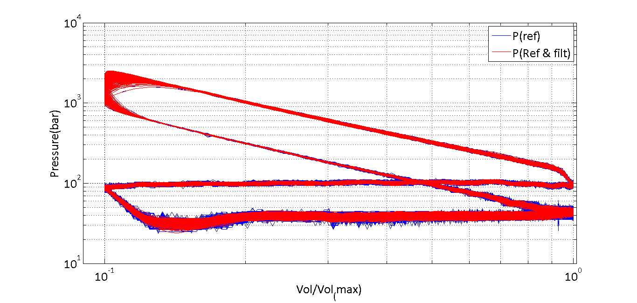

Figure 1a:Test 623 MBT spark timing 0% EGR

**Part I**

**Test 626 18% EGR)**

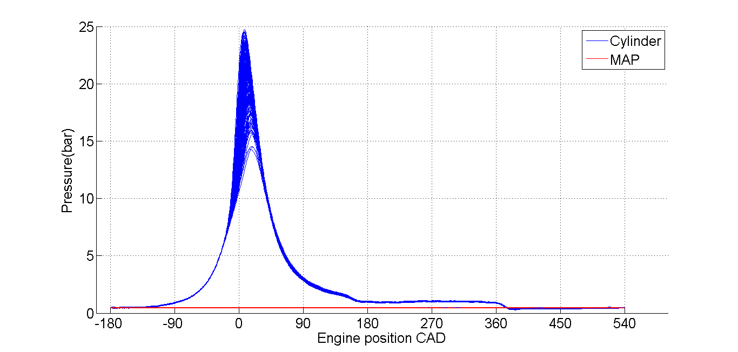

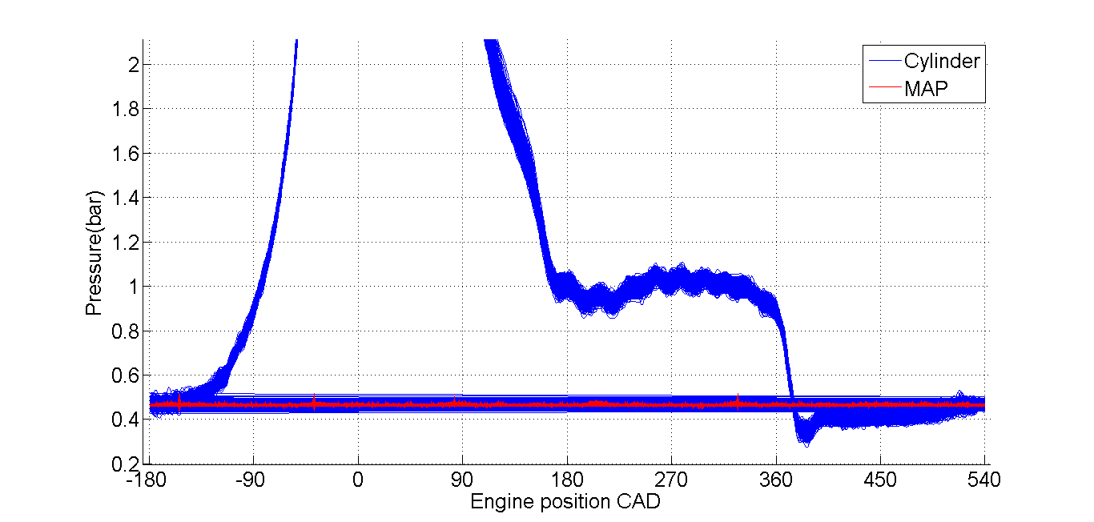

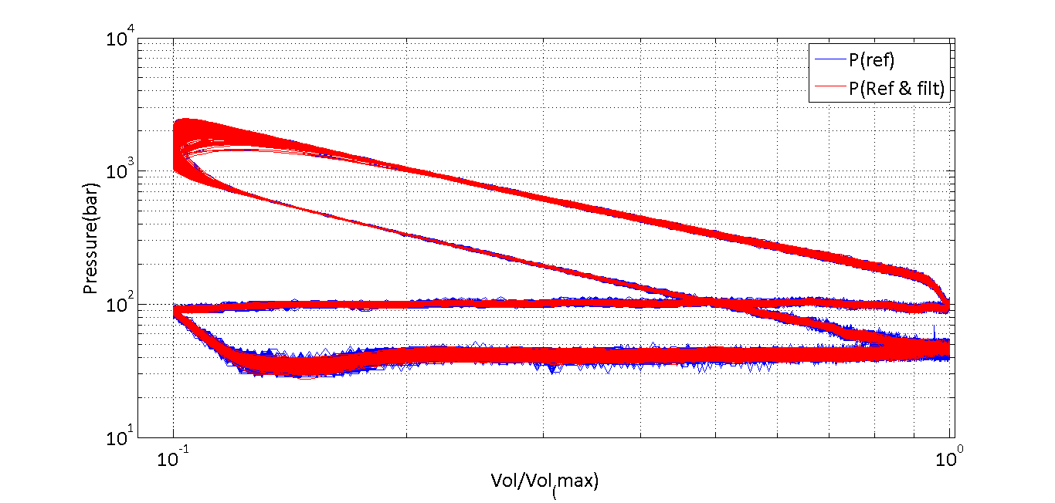

Figure 1b:Test 626 MBT spark timing 18% EGR **Part I**

**Test 631 (28% EGR)**

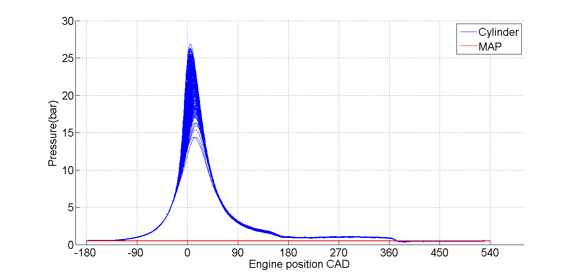

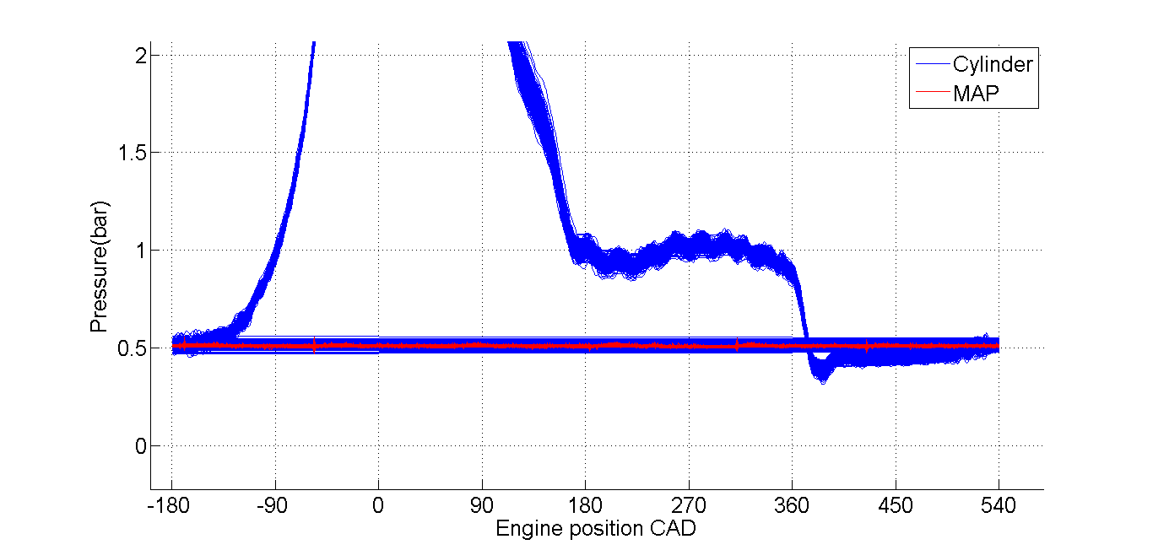

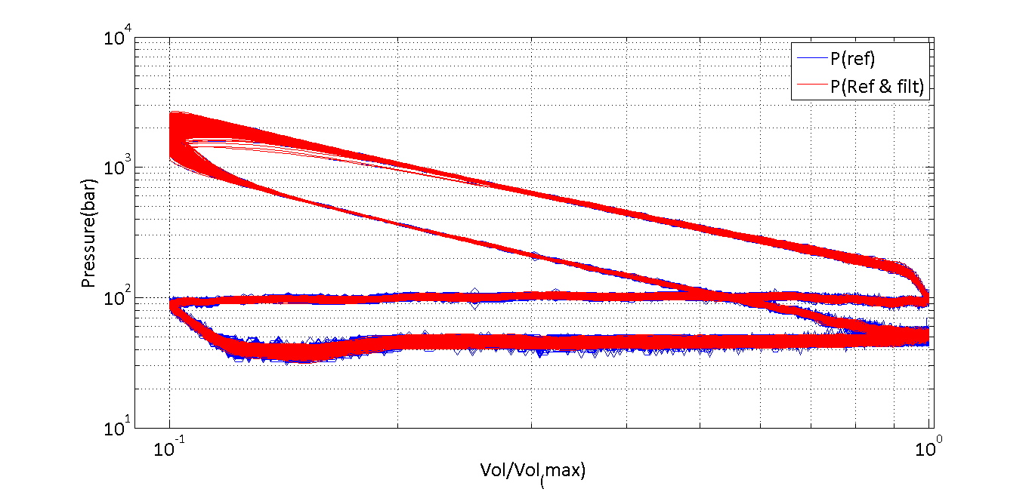

Figure 1c: Test 631 MBT spark timing 28%EGR

**Part II**

**Cycle Averaged**

**Test 623 (6% EGR)**

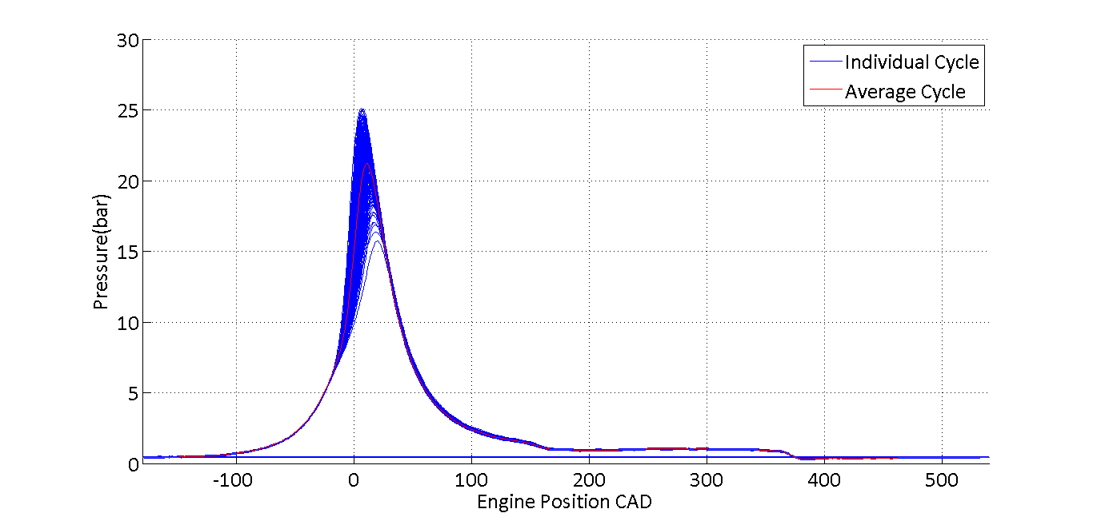

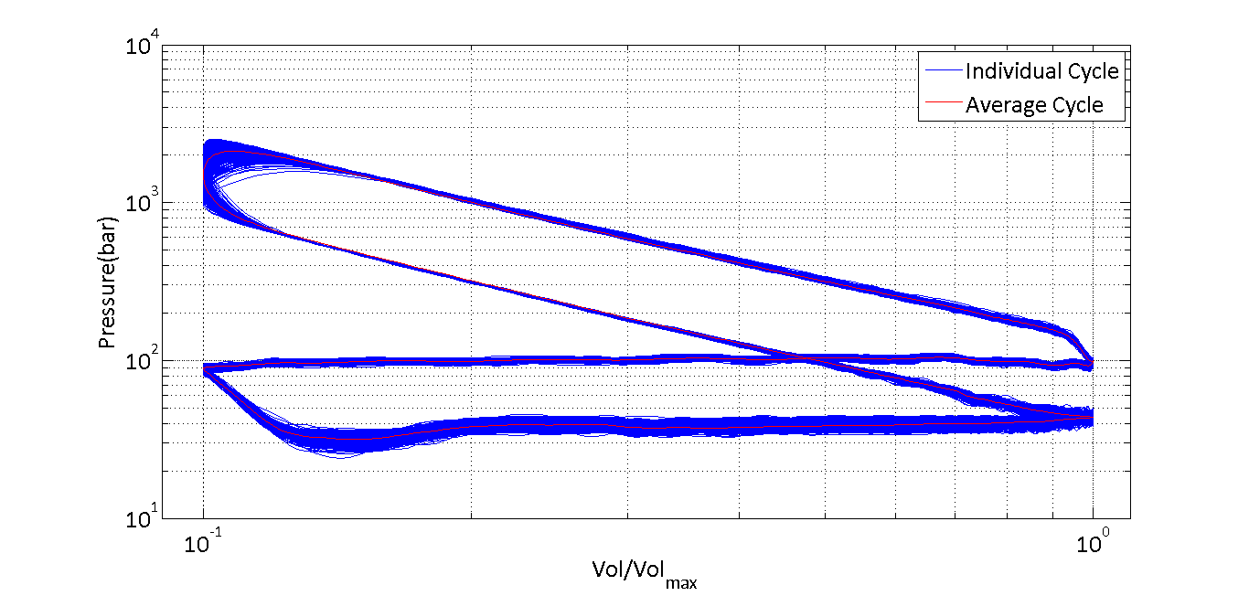

Figure 2a:Test 623 MBT spark timing 0% EGR-Cycle averaged

**Part II**

**Cycle Averaged**

**Test 626 (18% EGR)**

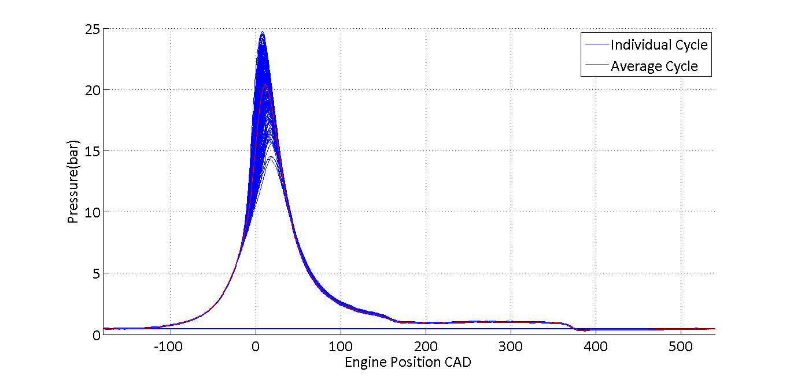

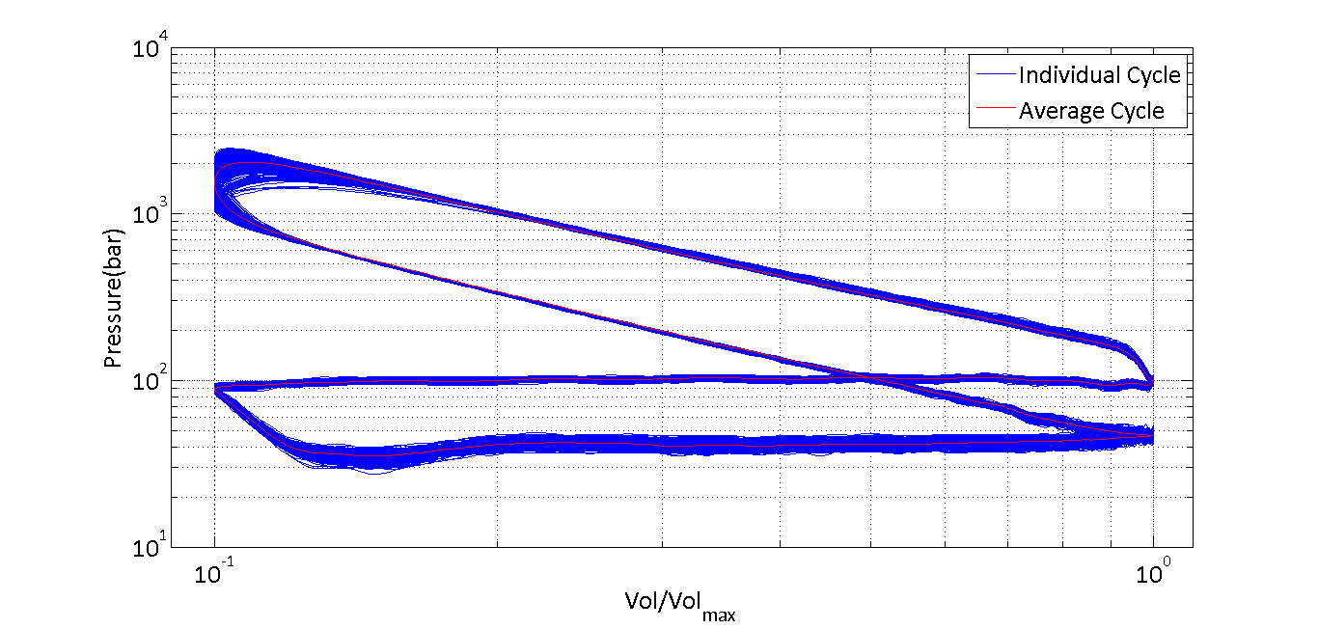

Figure 2b:Test 626 MBT spark timing 18% EGR-Cycle averaged

**Part II**

**Cycle Averaged**

**Test 631 (28% EGR)**

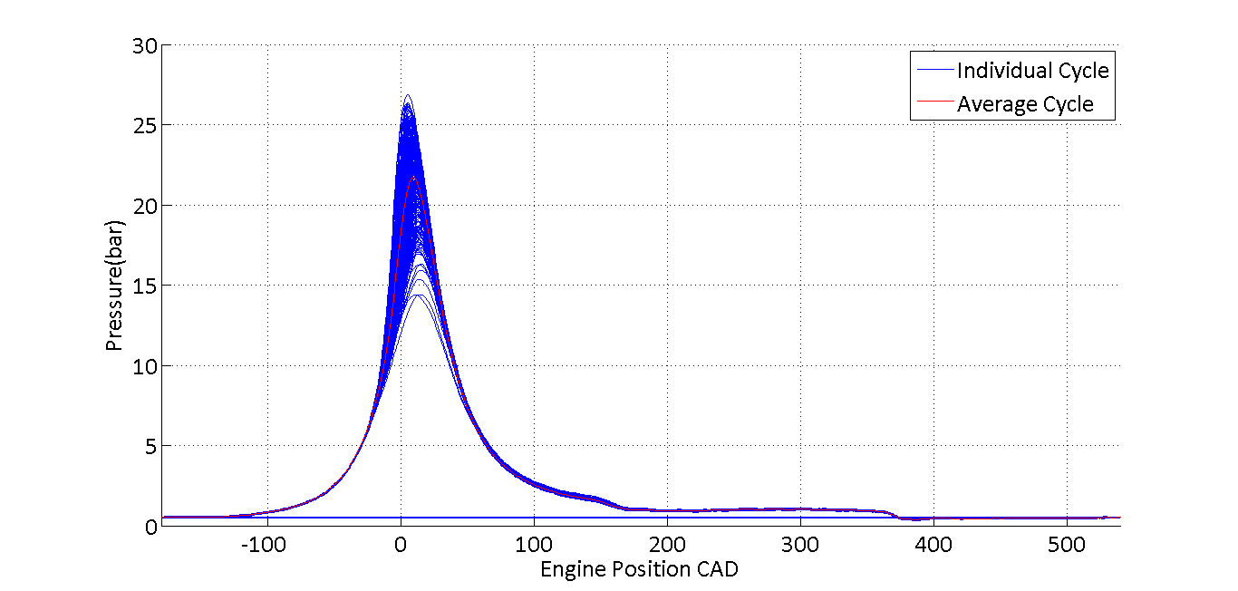

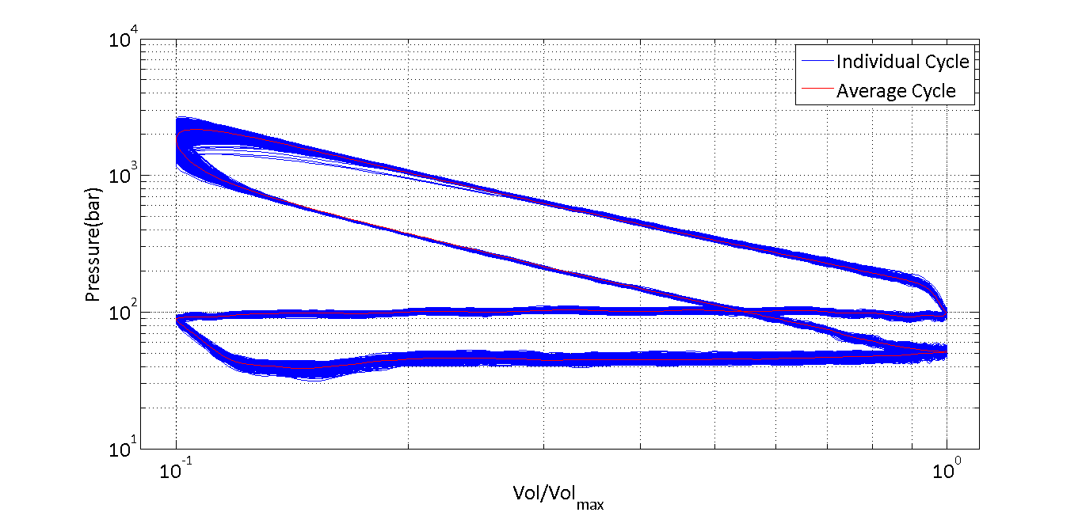Figure 2c: Test 631 MBT spark timing 28%EGR-Cycle averaged

Following observation can be made from first set of plots

1. From pressure v/s crank angle of the three plots, it can be seen that the maximum pressure in all the three plots is almost equal. From Matlab, it is found that maximum pressures for tests 623, 626 and 631 are 2.5bar. 2.4bar and 2.7bar respectively. It is also evident that max pressure occurs at about 5 deg ATDC
2. By zooming into the plot, it is evident that MAP is a constant with respect to crank angle. Hence, it provides an appropriate datum for calculating reference pressures which are unscaled. It can also be seen pressure in the exhaust stroke is almost a constant but well above MAP and pressure during intake stroke is slightly below MAP
3. The first observation that can be made from third figure is that the filter pressures are smooth when compared to actual pressure data. It can also be seen that work done during compression and expansion stroke in all the cycles is almost a constant. By closely examining the pump work reveals that Test 636 with 28% EGR requires much less pumping work when compared to others. This can be attributed to slightly higher percentage of EGR pumped into the cylinder at slightly higher pressure which reduces the load on the engine while executing a suction stroke.

Part II

Second set of figures contains two plots for each test. These set of figures demonstrate the same plot but with an averaged cycle over a set of 301 cycles for which data is provided. A linearly weighted mean has been calculated to obtain an average pressure v/s crank angle plot over 301 cycles and the same idea is extended while plotting the loglog plot of pressure v/s normalized volume. It is evident from thickness of the plots, especially close to TDC, that there is a lot of variance in all the tests especially during pressure rise at combustion. Hence it becomes necessary to calculate a mean value for each test so that all the cycles can be compared. Average plot (in red) passes through the centre of thickness which exhibits a symmetric nature of variance, that is, all the cycles are distributed equally about the mean. Hence, it can be concluded that the mean is a good way of representing the entire data using one cycle.

PART III

The following observations can be made from table 1 which presents the calculation of IMEPs for each test

* As EGR is increasing, the gross imep is decreasing. This means that the charge dilution by EGR is not generating more work during the compression and exhaust stroke. This can be due to increased charge density but no increase in charge energy density. The energy provided by the fuel in case of higher EGRs has to increase the heat of a higher mass and hence less work is produced. It can also be concluded that EGR does not possess unburned hydrocarbons as this would lead to increased energy addition in case of higher EGRs. This can be attributed to good combustion efficiency of the engine.
* It has already been discussed previously that the cycles exhibit variance. This is quantified by using coefficient of variance in the table. It is evident that the case with higher EGR has the highest variance. It can be concluded that pressures in this case vary a lot and any deductions made from the cycles are made with lower confidence due to high variance.
* Net imep is highest in case of 6% EGR. However, the proportion of net imep increase is not as high as gross imep increase when compared to other cycles. This is due to lower pumping work required as EGR percentage increases. This is evident from the imep pump column which clearly exhibits that the lowest pump work required is in the case of 28% EGR

|  |  |  |
| --- | --- | --- |
|  | $$IMEP_{net}=IMEP_{gross}- IMEP_{pump}$$ |  |

* Friction MEP is a characteristic of the engine. It is an mep component attributed to hindrance encountered by moving components of the engine while executing different strokes. As the same engine is used to perform tests, there should not be a lot of change in its value and is almost independent of the type od test being performed. This fact can be concluded from the last friction imep row of table 1. Also all the tests are performed at a constant BMEP of 2.62bar

|  |  |  |
| --- | --- | --- |
|  | $$BMEP=IMEP_{net}-FMEP$$ |  |

**Table 1 IMEP calculations for each test**

|  |  |  |  |  |
| --- | --- | --- | --- | --- |
| **Parameter** | **Unit** | **Test 623 6% EGR** | **Test 626**  **18% EGR** | **Test 631**  **28% EGR** |
| IMEP(GROSS) | (bar) | 3.49 | 3.43 | 3.39 |
| COV(IMEPG) | (%) | 1.14 | 1.34 | 2.08 |
| IMEP(NET) | (bar) | 2.87 | 2.84 | 2.86 |
| IMEP(PUMP) | (bar) | 0.62 | 0.59 | 0.53 |
| FMEP(Friction)[1] | (bar) | 0.25 | 0.22 | 0.24 |

**Appendix**

**MATLAB code used for generating plots**

%Purge%

clc

clear all

close all

%Extracting data from matrices

test623 = load('TEST623.mat');

test626 = load('TEST626.mat');

test631 = load('TEST631.mat');

%Convert time from ms to s

test623.T = (test623.T)*1000;

test626.T = (test626.T)*1000;

test631.T = (test631.T)*1000;

%Engine design parameter

r_c = 10;

V_c = 6.47*1e-05;

R = 3.5;

CA_623 = test623.CA;

CA_626 = test626.CA;

CA_631 = test631.CA;

%Pressures referenced

P_R_623 = ref_press(CA_623,test623.P,test623.MAP,530,540);

P_R_626 = ref_press(CA_626,test626.P,test626.MAP,530,540);

P_R_631 = ref_press(CA_631,test631.P,test631.MAP,530,540);

[b a] = butter(3,0.25);

P_R_623_f = filtfilt(b,a,P_R_623);

P_R_631_f = filtfilt(b,a,P_R_631);

P_R_626_f = filtfilt(b,a,P_R_626);

%Desired plots

figure

hold on

plot(CA_623,P_R_623_f./100);

plot(CA_623,test623.MAP./100,'r');

set(gca,'fontname','Calibr','fontsize',20,'XTick',[-180:90:540])

legend('Cylinder','MAP');

xlabel('Engine position CAD')

ylabel('Pressure(bar)')

grid on

hold off

figure

hold on

plot(CA_626,P_R_626_f./100);

plot(CA_626,test626.MAP./100,'r');

set(gca,'fontname','Calibr','fontsize',20,'XTick',[-180:90:540])

legend('Cylinder','MAP');

xlabel('Engine position CAD')

ylabel('Pressure(bar)')

grid on

hold off

figure

hold on

plot(CA_631,P_R_631_f./100);

plot(CA_631,test631.MAP./100,'r');

set(gca,'fontname','Calibr','fontsize',20,'XTick',[-180:90:540])

legend('Cylinder','MAP');

xlabel('Engine position CAD')

ylabel('Pressure(bar)')

grid on

hold off

figure

CA_180 = abs(wrapTo180(CA_623));

V = V_c*(1 + 0.5*(r_c-1)*(R + 1 - cosd(CA_180) - (R^2-sind(CA_180).^2).^0.5));

V_norm = V./max(V);

loglog(V_norm,P_R_623,V_norm,P_R_623_f,'r')

set(gca,'XMinorGrid','Off','fontname','Calibri','fontsize',20,'XLim',[(0.1-0.01) 1.015])

xlabel('Vol/Vol_(max)')

ylabel('Pressure(bar)')

legend('P(ref)','P(Ref & filt)')

grid

figure

CA_180 = abs(wrapTo180(CA_626));

V = V_c*(1 + 0.5*(r_c-1)*(R + 1 - cosd(CA_180) - (R^2-sind(CA_180).^2).^0.5));

V_norm = V./max(V);

loglog(V_norm,P_R_626,V_norm,P_R_626_f,'r')

set(gca,'XMinorGrid','Off','fontname','Calibri','fontsize',20,'XLim',[(0.1-0.01) 1.015])

xlabel('Vol/Vol_(max)')

ylabel('Pressure(bar)')

legend('P(ref)','P(Ref & filt)')

grid

figure

CA_180 = abs(wrapTo180(CA_631));

V = V_c*(1 + 0.5*(r_c-1)*(R + 1 - cosd(CA_180) - (R^2-sind(CA_180).^2).^0.5));

V_norm = V./max(V);

loglog(V_norm,P_R_631,V_norm,P_R_631_f,'r')

set(gca,'XMinorGrid','Off','fontname','Calibri','fontsize',20,'XLim',[(0.1-0.01) 1.015])

xlabel('Vol/Vol_(max)')

ylabel('Pressure(bar)')

legend('P(ref)','P(Ref & filt)')

grid

%Code for mean

%623%

n_cyl = floor(length(CA_623)/720);

n = n_cyl*720;

i_start = min(find(CA_623<-179));

ii = (0:n-1) + i_start;

P_R_623_mat = reshape(P_R_623_f(ii), 720, n_cyl);

P_R_623_avg = mean(P_R_623_mat,2);

figure

hold on

plot(CA_623,P_R_623_f./100)

plot(linspace(-180,540,720),P_R_623_avg./100,'r')

set(gca,'fontname','Calibri','fontsize',20,'XLim',[-180 540])

xlabel('Engine Position CAD')

ylabel('Pressure(bar)')

legend('Individual Cycle','Average Cycle')

grid on

hold off

figure

CA_180 = abs(wrapTo180(CA_623));

V = V_c*(1 + 0.5*(r_c-1)*(R + 1 - cosd(CA_180) - (R^2-sind(CA_180).^2).^0.5));

V_norm = V./max(V);

CA_180_mean = abs(wrapTo180(linspace(-180,540,720)));

V_avg = V_c*(1 + 0.5*(r_c-1)*(R + 1 - cosd(CA_180_mean) - (R^2-sind(CA_180_mean).^2).^0.5));

V_avg_norm = V_avg./max(V_avg);

loglog(V_norm,P_R_623_f,V_avg_norm,P_R_623_avg,'r')

set(gca,'fontname','Calibri','fontsize',20,'XLim',[0.1-0.01 1+0.1],'XMinorGrid','Off')

xlabel('Vol/Vol_{max}')

ylabel('Pressure(bar)')

legend('Individual Cycle','Average Cycle')

grid

W_623 = Work_cyc(P_R_623_avg,V_avg);

W_623_gross = Work_cyc(P_R_623_avg(1:360),V_avg(1:360));

W_623_mat = zeros(301,1);

V_mat = reshape(V(ii),720,301);

for i = 1:301

W_623_mat(i,1) = Work_cyc(P_R_623_mat(1:360,i),V_mat(1:360,i));

end

IMEP_623 = W_623_mat./(5.82*1e-02);

COV_623=std(IMEP_623)/mean(IMEP_623)

%626%

n_cyl = floor(length(CA_626)/720);

n = n_cyl*720;

i_start = min(find(CA_626<-179));

ii = (0:n-1) + i_start;

P_R_626_mat = reshape(P_R_626_f(ii), 720, n_cyl);

P_R_626_avg = mean(P_R_626_mat,2);

figure

hold on

plot(CA_626,P_R_626_f./100)

plot(linspace(-180,540,720),P_R_626_avg./100,'r')

set(gca,'fontname','Calibri','fontsize',20,'XLim',[-180 540])

xlabel('Engine Position CAD')

ylabel('Pressure(bar)')

legend('Individual Cycle','Average Cycle')

grid

hold off

figure

CA_180 = abs(wrapTo180(CA_626));

V = V_c*(1 + 0.5*(r_c-1)*(R + 1 - cosd(CA_180) - (R^2-sind(CA_180).^2).^0.5));

V_norm = V./max(V);

CA_180_mean = abs(wrapTo180(linspace(-180,540,720)));

V_avg = V_c*(1 + 0.5*(r_c-1)*(R + 1 - cosd(CA_180_mean) - (R^2-sind(CA_180_mean).^2).^0.5));

V_avg_norm = V_avg./max(V_avg);

loglog(V_norm,P_R_626_f,V_avg_norm,P_R_626_avg,'r')

set(gca,'fontname','Calibri','fontsize',20,'XLim',[0.1-0.01 1+0.1],'XMinorGrid','Off')

xlabel('Vol/Vol_{max}')

ylabel('Pressure(bar)')

legend('Individual Cycle','Average Cycle')

grid

W_626 = Work_cyc(P_R_626_avg,V_avg)

W_626_gross = Work_cyc(P_R_626_avg(1:360),V_avg(1:360))

W_626_mat = zeros(301,1);

V_mat = reshape(V(ii),720,301);

for i = 1:301

W_626_mat(i,1) = Work_cyc(P_R_626_mat(1:360,i),V_mat(1:360,i));

end

IMEP_626 = W_626_mat./(5.82*1e-02);

COV_626=std(IMEP_626)/mean(IMEP_626)

%631%

n_cyl = floor(length(CA_631)/720);

n = n_cyl*720;

i_start = min(find(CA_631<-179));

ii = (0:n-1) + i_start;

P_R_631_mat = reshape(P_R_631_f(ii), 720, n_cyl);

P_R_631_avg = mean(P_R_631_mat,2);

figure

hold on

plot(CA_631,P_R_631_f./100)

plot(linspace(-180,540,720),P_R_631_avg./100,'r')

set(gca,'fontname','Calibri','fontsize',20,'XLim',[-180 540])

xlabel('Engine Position CAD')

ylabel('Pressure(bar)')

legend('Individual Cycle','Average Cycle')

grid

hold off

figure

CA_180 = abs(wrapTo180(CA_631));

V = V_c*(1 + 0.5*(r_c-1)*(R + 1 - cosd(CA_180) - (R^2-sind(CA_180).^2).^0.5));

V_norm = V./max(V);

CA_180_mean = abs(wrapTo180(linspace(-180,540,720)));

V_avg = V_c*(1 + 0.5*(r_c-1)*(R + 1 - cosd(CA_180_mean) - (R^2-sind(CA_180_mean).^2).^0.5));

V_avg_norm = V_avg./max(V_avg);

loglog(V_norm,P_R_631_f,V_avg_norm,P_R_631_avg,'r')

set(gca,'fontname','Calibri','fontsize',20,'XLim',[0.1-0.01 1+0.1],'XMinorGrid','Off')

xlabel('Vol/Vol_{max}')

ylabel('Pressure(bar)')

legend('Individual Cycle','Average Cycle')

grid

W_631 = Work_cyc(P_R_631_avg,V_avg)

W_631_gross = Work_cyc(P_R_631_avg(1:360),V_avg(1:360))

W_631_mat = zeros(301,1);

V_mat = reshape(V(ii),720,301);

for i = 1:301

W_631_mat(i,1) = Work_cyc(P_R_631_mat(1:360,i),V_mat(1:360,i));

end

IMEP_631 = W_631_mat./(5.82*1e-02);

COV_631=std(IMEP_631)/mean(IMEP_631)

**Grade Sheet**

Student Name: *Arjun Darbha .*

|  |  |  |
| --- | --- | --- |
| **Area** | **Points** | **Score** |
| Cover Sheet | 5 |  |
| Introduction | 5 |  |
| Parts I-VI (20 points each, 15 points for figures and tables and 5 points for discussion and explanations of method). |  |  |
| Part I | 20 |  |
| Part II | 20 |  |
| Part III | 20 |  |
| Format for Report & Code – following submission  instructions | 10 |  |
| **Total Parts (I-III)** | **80** |  |

1. Based upon a BMEP of 2.62 bar.